1.Write a Pandas program to select the distinct department id from employees file.
Program:
import pandas as pd
# Create Employees dataset
employees = pd.DataFrame({
"Employee_ID": [101, 102, 103, 104, 105, 106],
"Employee_Name": ["John", "Alice", "Bob", "David", "Emma", "Frank"],
"Department_ID": [10, 20, 10, 30, 20, 40]
})
# Display dataset
print("Employees Dataset:")
print(employees)
# Select distinct Department IDs
distinct_departments = employees["Department_ID"].drop_duplicates()
print("\nDistinct Department IDs:")
print(distinct_departments.to_string(index=False))
Output:
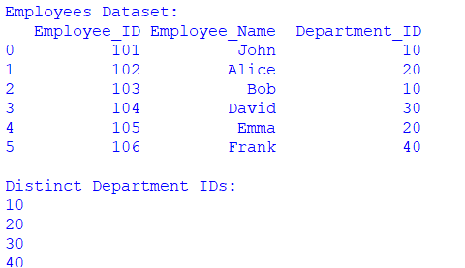

2. Write a Pandas program to display the IDs of employees who have done two or more
Program:
import pandas as pd
#Create employee dataset
employees = pd.DataFrame({
"Employee_ID": [101, 102, 103, 104, 105, 106],
"Employee_Name": ["John", "Alice", "Bob", "David", "Emma", "Frank"],
"Tasks_Completed": [3, 1, 5, 2, 1, 4]
})
print("Employees Dataset:")
print(employees)
# Select employees who completed two or more tasks
result = employees[employees["Tasks_Completed"] >= 2]

print("\nEmployee IDs who have completed two or more tasks:")
print(result["Employee_ID"].to_string(index=False))
Output:
